01st September 2016

World Touring Car Championship in Japan

The strong Motorsport passion that is an integral part of Japanese culture and an essential platform for the development of automotive technology worldwide, will celebrate the FIA World Touring Car Championship racing at Twin Ring Motegi this weekend.

For the second year in a row, following a move from the Suzuka Race track which proved very popular and the new option offering arguably more excitement and overtaking possibilities, new hope and expectations are once again in the hearts and minds of the racing teams participating in the World Championship which boasts the premium Japanese Tyre manufacturer YOKOHAMA as its Official Tyre supplier.

With a dominant leader on his last season with the Championship, as he will move on to another category of motorsports, Jose Maria “Pechito” Lopez will surely go all out once again, to continue stretching his lead and legend within his short but incredibly successful career in the WTCC, winning back to back Championships in his first two seasons already and now aiming to secure a historical third consecutive title.

With the Japanese car manufacturer Honda racing team also strongly represented by Huff, Monteiro and Michelisz and newcomer for the occasion Michigami, the stakes are high for the thrills and spills of racing. In addition to those competing for the top places, the veterans Tarquini and Coronel also have fond memories of successfully racing in Japan and consider it a highlight in their calendar year and will certainly aim to replicate their biggest moments in the land of the rising sun.

“Motorsport is in YOKOHAMA’s DNA and helps us to continue developing and enhancing our tyre technology”, the benefits of which are then passed on to our passenger car tyres”, stated David Oliva, responsible for YOKOHAMA Europe communications. “The race in Japan is a special one for us as we consider it the home race, although as a truly global company nearing our centenary, we feel comfortable at every race track in the world, whether it is at the Nürburgring or in Qatar, he added. Our Motorsport support team is ready and we are looking forward to the challenge.”

This particular race weekend will also be challenging to some new drivers competing, such as Ryo Michigami a former Super GT racer, getting his first shot at the WTCC on a factory Honda Civic at his home event and Nestor Girolami from Argentina who will make his debut for Polestar Cyan Racing and will be the first non-swede to drive a Volvo S60 Polestar TC1. “It certainly has all the ingredients to offer an exciting weekend ahead of top motorsports action.” Concluded the spokesman for YOKOHAMA.

Current Overall Driver Standings

1. Jose Maria Lopez 284pts
2. Thiago Monteiro 167pts
3. Yvan Muller 160pts
4. Rob Huff 158pts

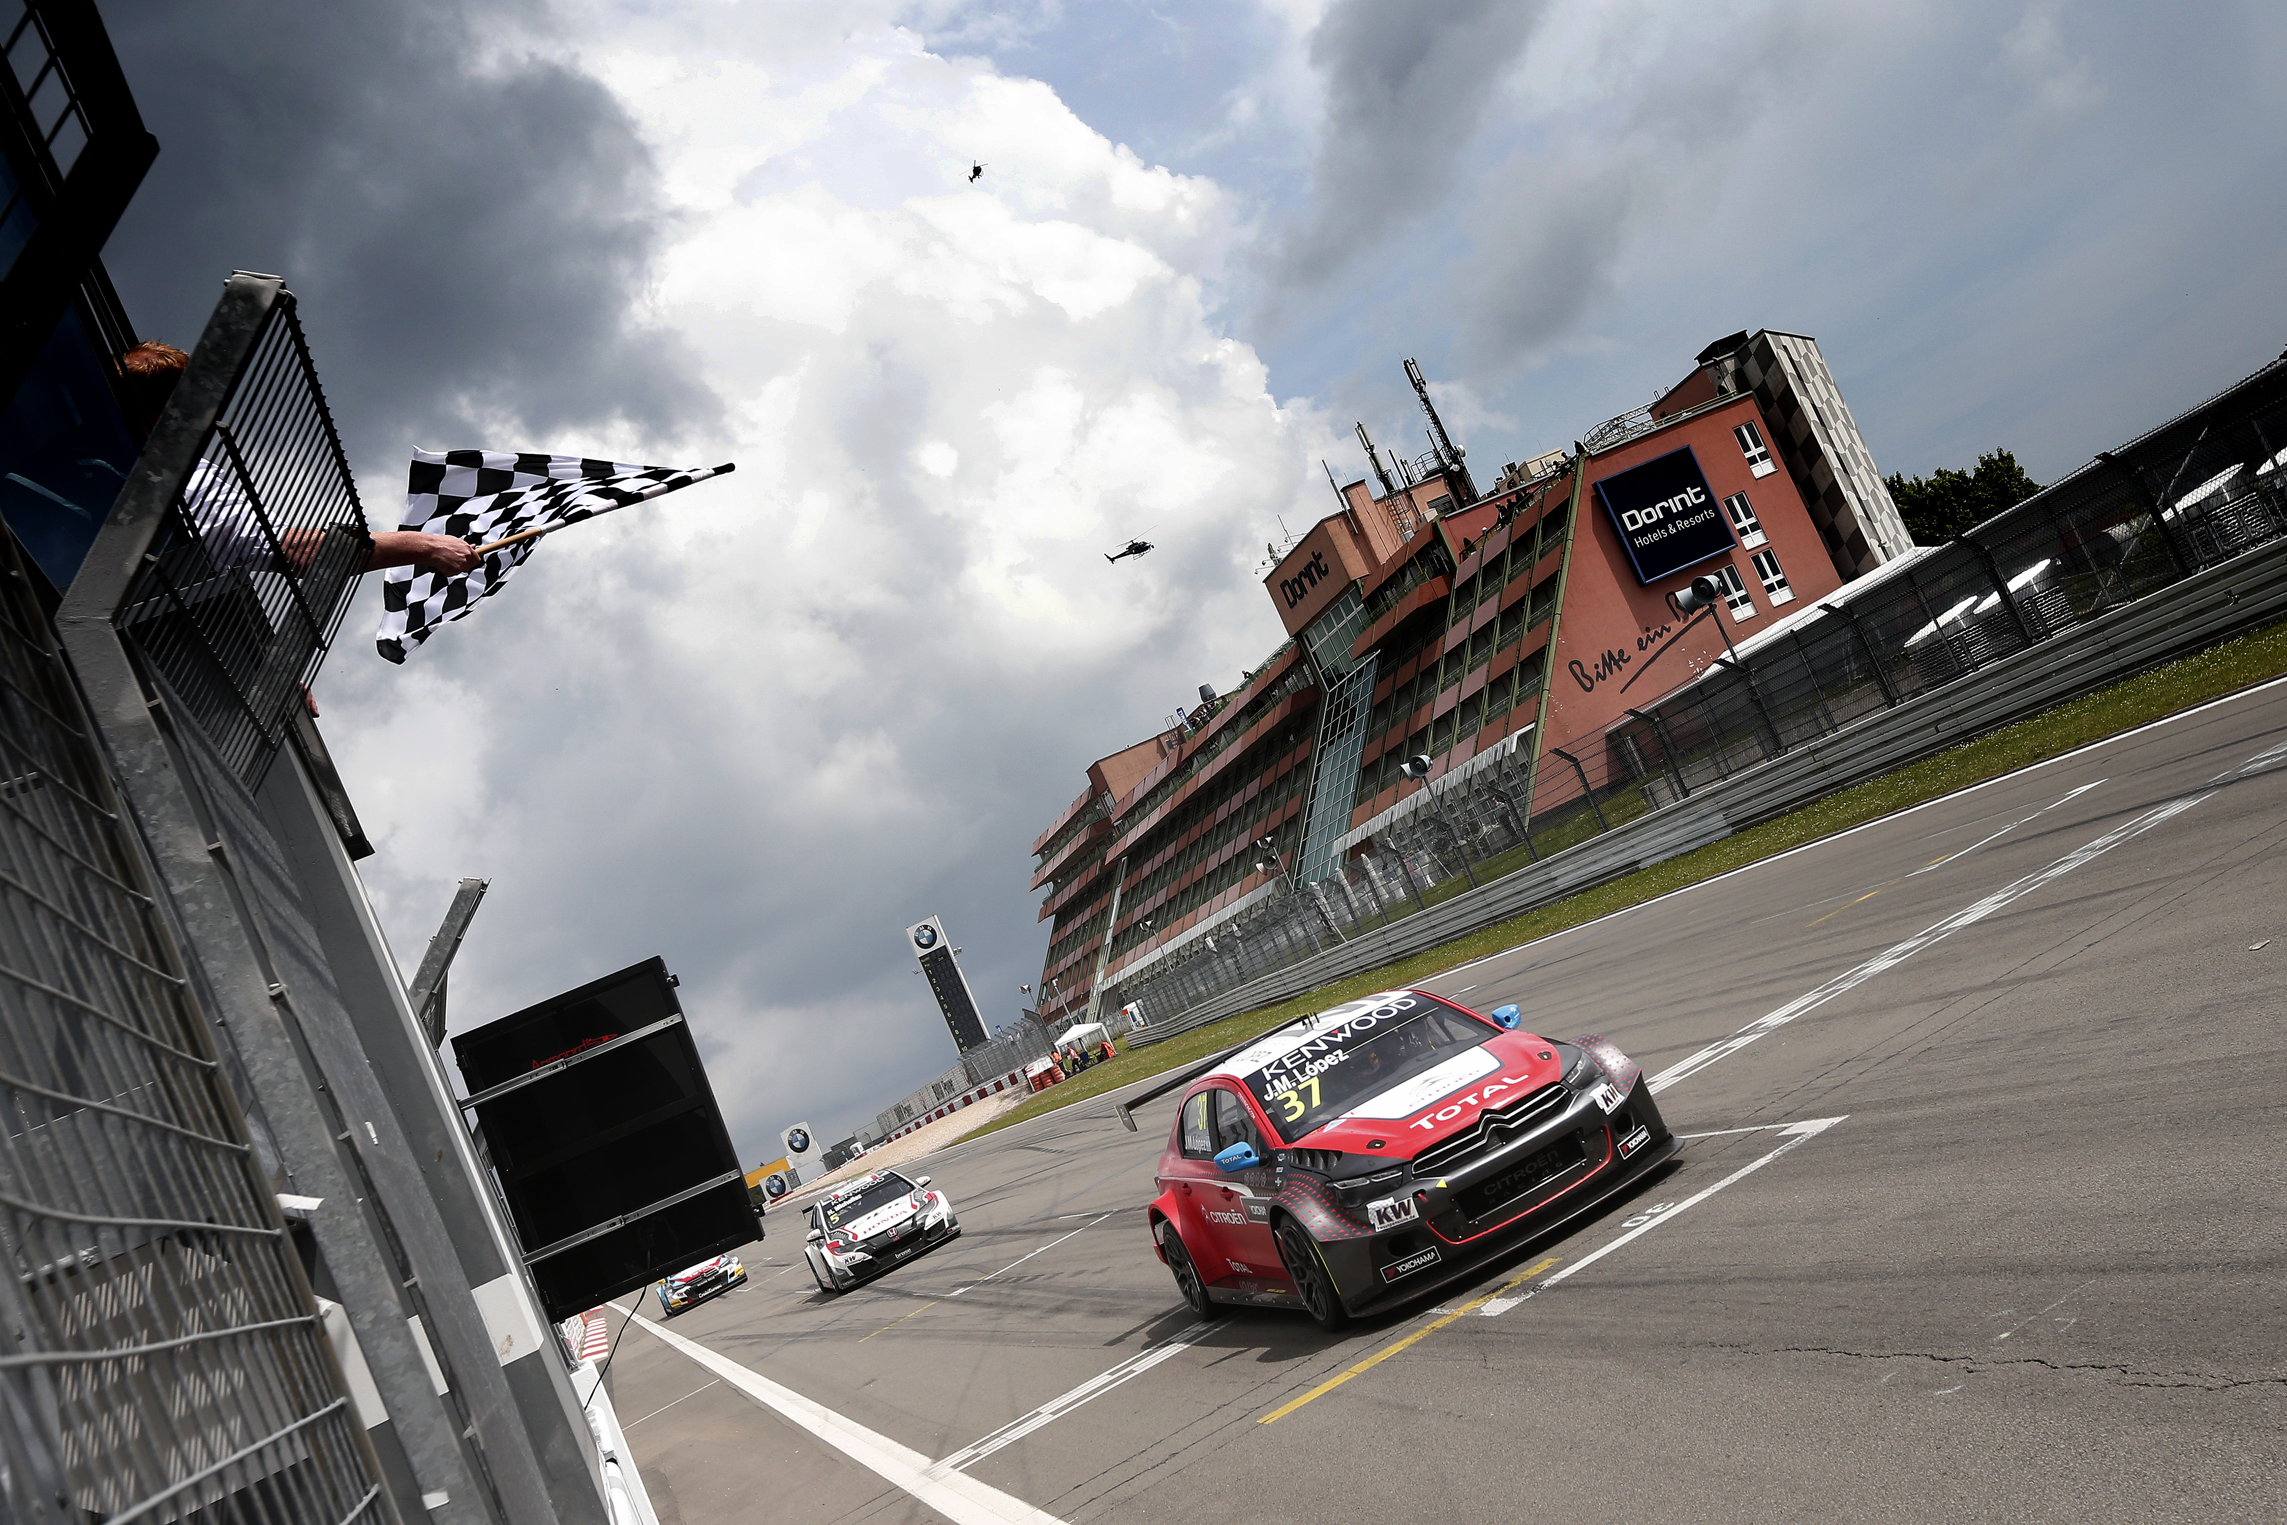
Lopez at the Nurburgring

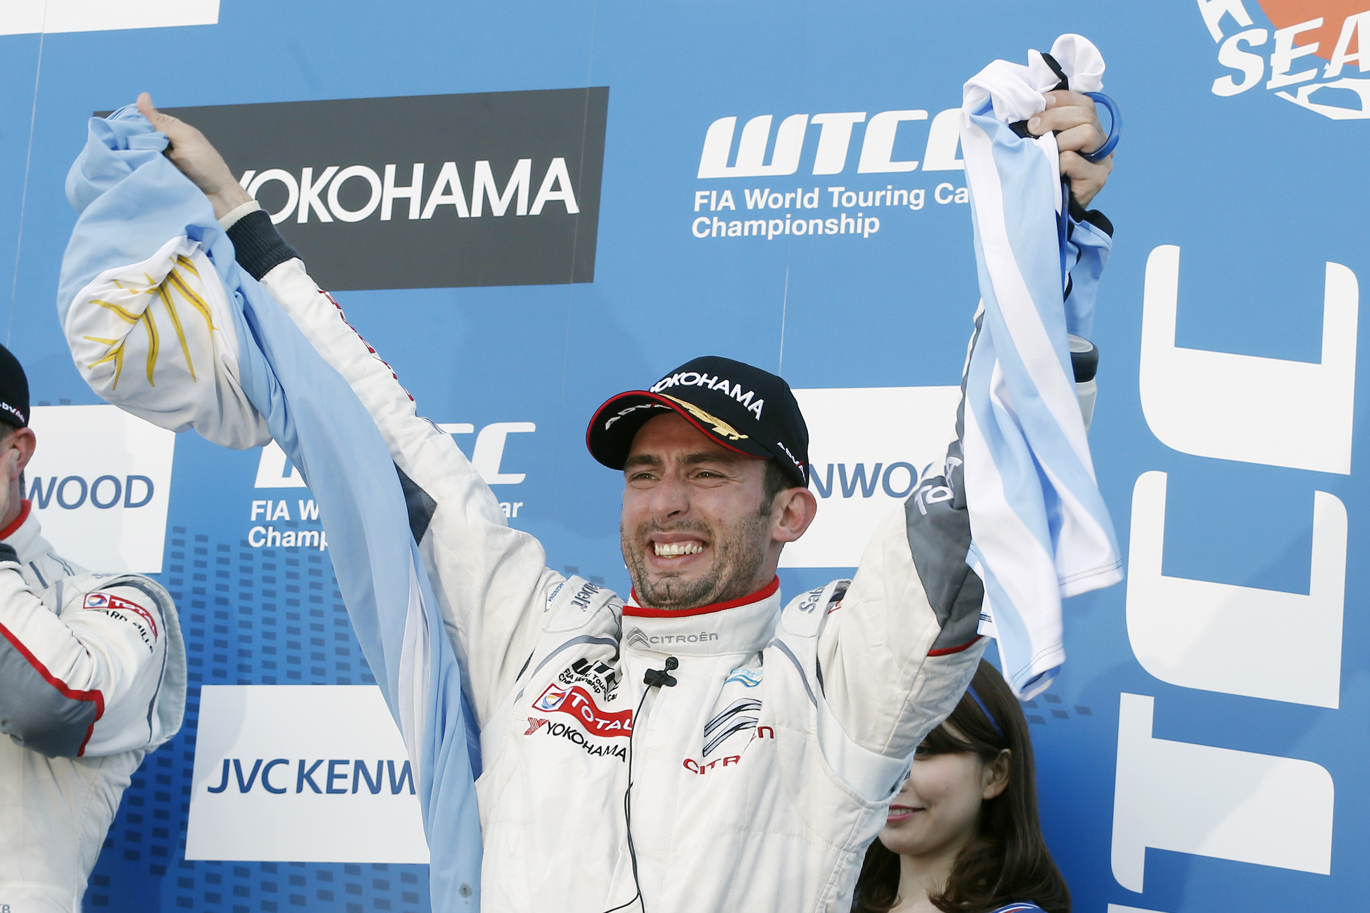
Lopez celebrating first victory in Japan in 2014

